|  |
| --- |
| Queensland University of Technology |
| **Personal Portfolio** |
| Pink Spoon – Group 15 |

|  |
| --- |
| James Uprichard – N10077596  5-31-2018 |

Table of Contents

**Artefact 1** – (Use Case Diagram) 2

**Artefact 2** – (Sprint 2 ERD) 3

**Artefact 3** – (Payment Page) 4

**Artefact 4** – (Bitbucket and message Logs) 5

**Artefact 5** – (Html & CSS Validation) 6

# **Artefact 1** – (Use Case Diagram)

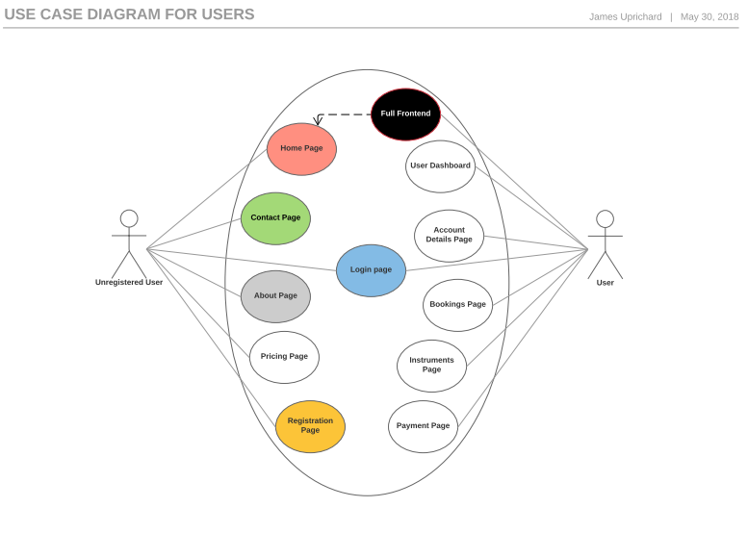

The UCD (Use Case Diagram) was a vital section of information that made the creation for the website interaction easier to follow. The UCD helped the development team discuss and decide with the client how the user permissions would be implemented for the website.

# **Artefact 2** – (Sprint 2 ERD)

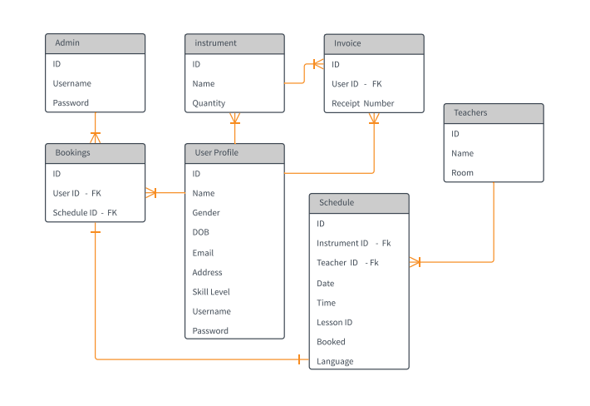

From the sprint 1 ERD the development team made changes to the database by dropping tables and adding new tables with a more structured relationships between each entity. Having This diagram allowed the development team members to understand how the different entities interact with each other.

As the website was built in different stages the team had to update or create many different iterations of this diagram. The ERD above is the final iteration, all tables and columns are exact matches for the tables in our database for the website.

# **Artefact 3** – (Payment Page)

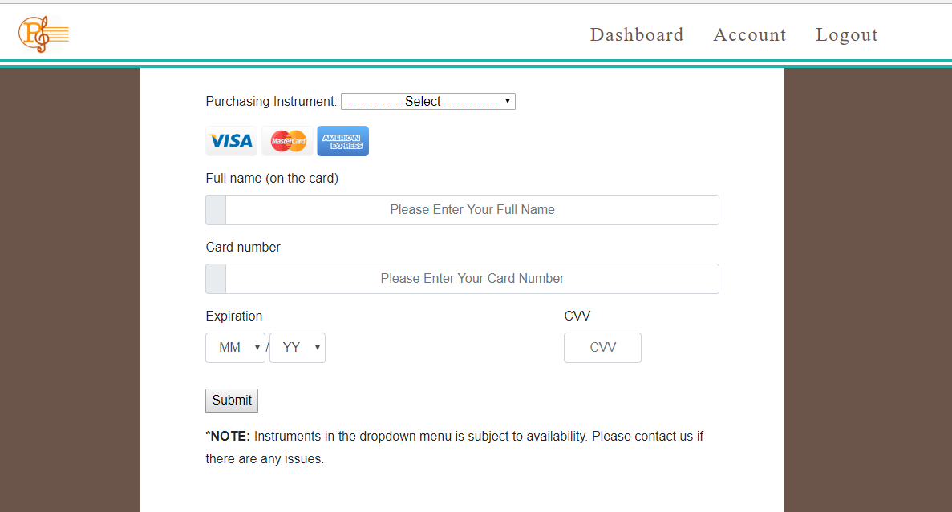

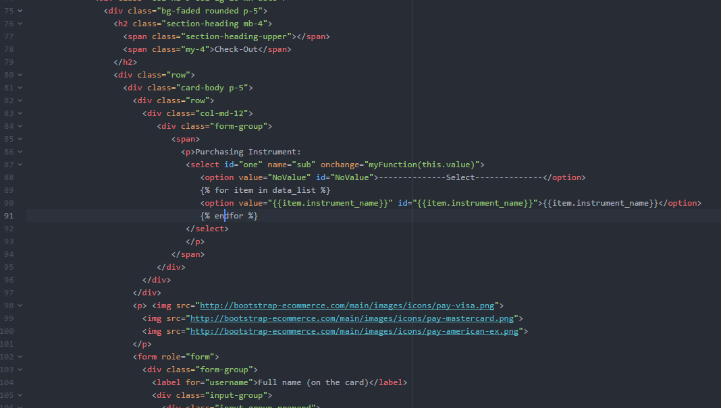

The payment process page was difficult to get working as the website is not live or dose not have HTTPS certificates. This payment page can be made fully functional by a few simple lines of code. In keeping with the rest of the website bootstrap classes and IDs were used to make the form match the design for the client.

# **Artefact 4** – (Bitbucket and message Logs)

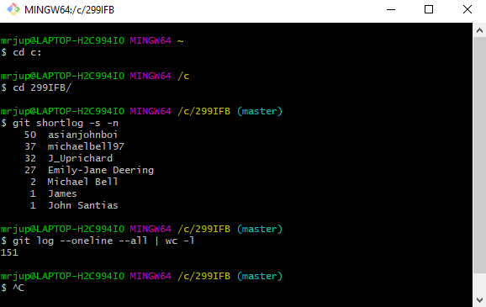

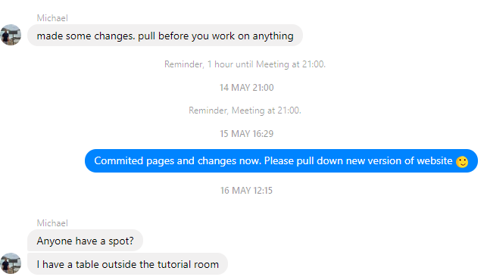

Tracking teams commits to bitbucket has been important thought Sprint 1 and Sprint 2, to see contribution, team work and communication. As a team when a member committed changes to the website that member would post a message on our team Facebook group chat so that other member could pull down the newest version of the website before adding or implementing changes.

# **Artefact 5** – (Html & CSS Validation)

Validating HTML and CSS are very important steps in the development of a web application, without validation the web application can/could crash on different devices or different browsers. The validation below shows the first and the last validation ran on the index.html page and the styles.css file. With validation if there are any errors and or warnings in the html and CSS code this can be easily corrected as the validator show the developer the line in the code where the error has occurred and a description for warnings.

Test 1.

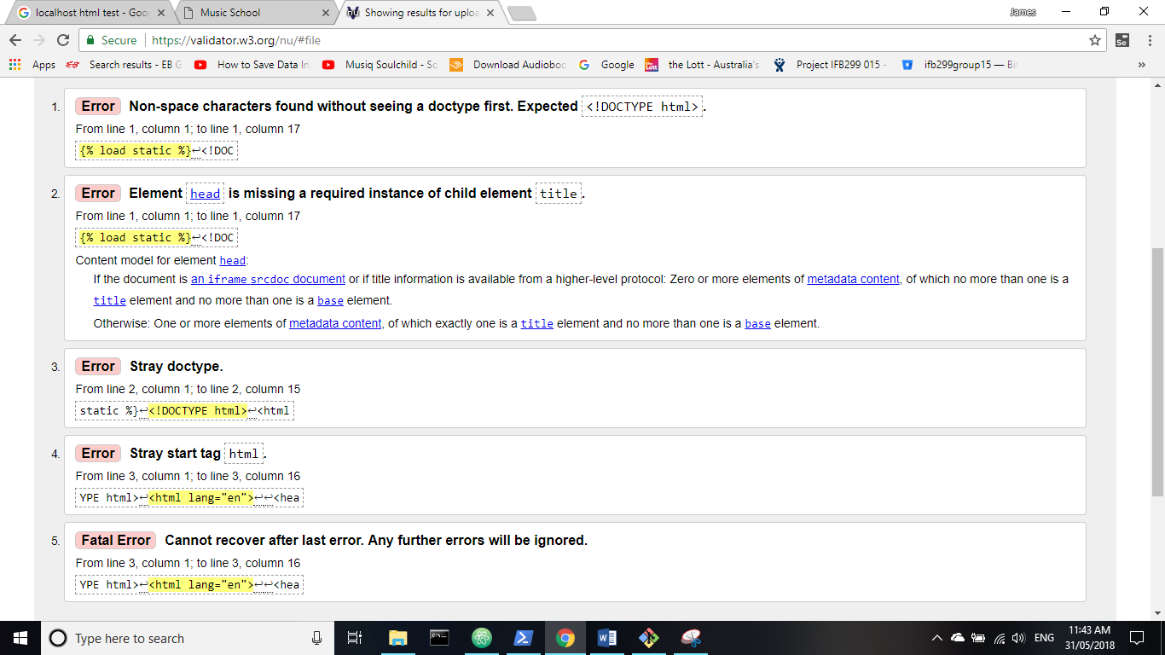

Test 2.

The errors that the validator is still showing are because the validator is looking at only HTML5 and not the Django coding methods.

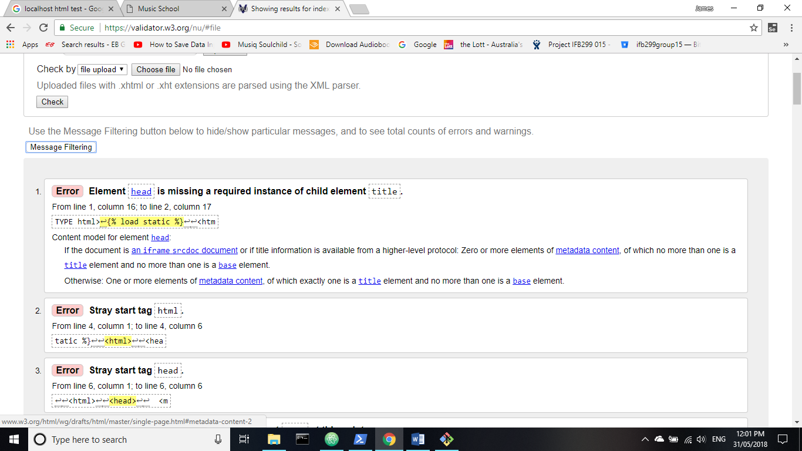

CSS Test 1.

